Reporting analyst Interview questions

Name: | Start time:
Date: | End time:

VBA:
1. What is the difference between ByVal and ByRef and which is default?

2. What is the meaning of Option Base?

3. Write a VBA script which will create Isosceles triangle (two equal sides, two equal angles). Example of the output shown below:
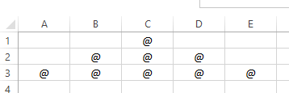

Your VBA code:

4. Code to find a Last used Row in a column or Last used column of a Row.

5. Explain the difference between Class, Module, Subroutine and Function.

6. What is the difference between OLEDB & ODBC?

7. What is a Variant, what the pros and cons of its use?

8. What is a volatile function?

10. What is the difference between UsedRange and CurrentRegion properties?

